Controlling a Stepper Motor

It has 200 steps per revolution, and can operate at at 60 RPM. If you don't already have the step and speed value for your motor, find out now and you will need it for the sketch.

The key to successful stepper motor control is identifying the wires - that is which one is which. You will need to determine the A+, A-, B+ and B- wires. With our example motor these are red, green, yellow and blue. Now let's get the wiring done.

Connect the A+, A-, B+ and B- wires from the stepper motor to the module connections 1, 2, 13 and 14 respectively. Place the jumpers included with the L298N module over the pairs at module points 7 and 12. Then connect the power supply as required to points 4 (positive) and 5 (negative/GND).

Once again if your stepper motor's power supply is less than 12V, fit the jumper to the module at point 3 which gives you a neat 5V power supply for your Arduino.

Next, connect L298N module pins IN1, IN2, IN3 and IN4 to Arduino digital pins D8, D9, D10 and D11 respectively. Finally, connect Arduino GND to point 5 on the module, and Arduino 5V to point 6 if sourcing 5V from the module.

Controlling the stepper motor from your sketches is very simple, thanks to the Stepper Arduino library included with the Arduino IDE as standard.

To demonstrate your motor, simply load the stepper_oneRevolution sketch that is included with the Stepper library, for example:

Finally, check the value for

const int stepsPerRevolution = 200;

in the sketch and change the 200 to the number of steps per revolution for your stepper motor, and also the speed which is preset to 60 RPM in the following line:

myStepper.setSpeed(60);

Now you can save and upload the sketch, which will send your stepper motor around one revolution, then back again. This is achieved with the function

myStepper.step(stepsPerRevolution); // for clockwise

myStepper.step(-stepsPerRevolution); // for anti-clockwise

Finally, a quick demonstration of our test hardware is shown in the following video:

<https://youtu.be/F-1sfpeTFPc>

Schematic of L298

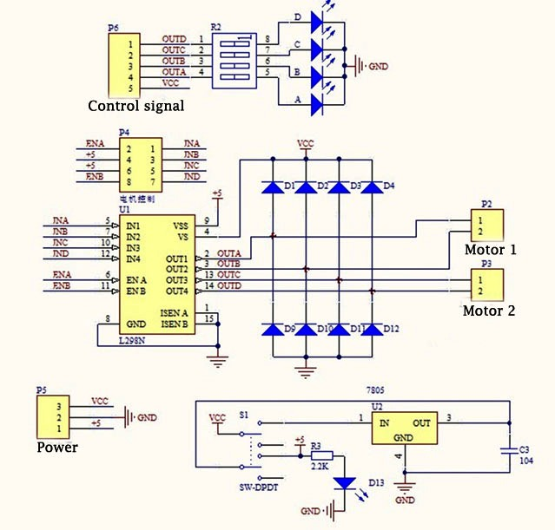

EXCITATION OF A STEPPER MOTOR:

### ****Full step and half step****

Stepper drives control how a stepper motor operates, there are three commonly used excitation modes for stepper motors, full step, half step and microstepping. These excitation modes have an effect on both the running properties and torque the motor delivers.

A stepper motor converts electronic signals into mechanical movement each time an incoming pulse is applied to the motor. Each pulse moves the shaft in fixed increments. If the stepper motor has a 1.8° step resolution, then in order for shaft to rotate one complete revolution, in full step operation, the stepper motor would need to receive 200 pulses, 360° ÷ 1.8 = 200.

There are two types of full step excitation modes.

In one-phase on - full step, Fig1, the motor is operated with only one phase energized at a time. This mode requires the least amount of power from the driver of any of the excitation modes.

In two-phase on - full step, Fig2, the motor is operated with both phases energized at the same time. This mode provides improved torque and speed performance. Two-phase on provides about 30% to 40% more torque than one phase on, however it requires twice as much power from the driver.

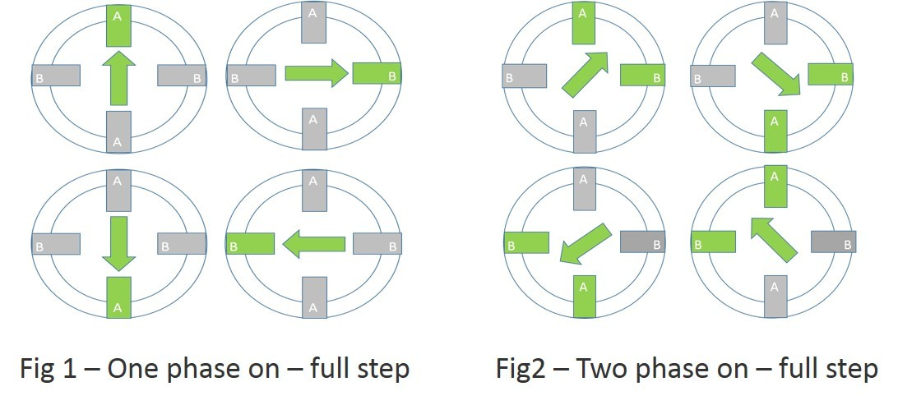

Half step excitation mode is a combination of one phase on and two phase on full step modes. This results in half the basic step angle. This smaller step angle provides smoother operation due the increased resolution of the angle.

Half step produces about 15% less torque than two phase on - full step, however modified half stepping eliminates the torque decrease by increasing the current applied to the motor when a single phase is energized. See Fig3

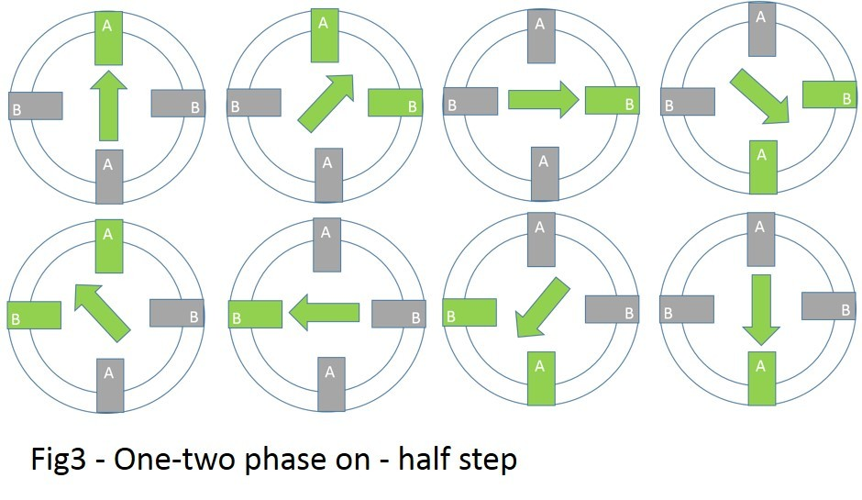

#### **Microstepping for greater control and smoother operation**

Microstepping can divide a motor’s basic step by up to 256 times, making small steps smaller. A Micro drive uses two current sinewaves 90° apart, this is perfect for enabling smooth running of the motor. You will notice that the motor runs is quietly and with no real detectable stepping action.

By controlling direction and amplitude of the current flow in each winding, the resolution increases and the characteristics of the motor improve, giving less vibration and smoother operation. Because the sinewaves work together there is a smooth transition from one winding to the other. When current increases in one it decreases in the other resulting in a smooth step progression and maintained torque output. See Fig4

